**Git & GitHub Lab**

1. Download the microservice skeleton from Spring Initializer.  
   Select the following options while downloading the microservice skeleton

Project: Maven

Language: Java

Spring Boot: 3.3.7

Rename the Artifact in Project (e.g. netflix-ms)

Packaging: Jar

Java Version: 21

Add Dependencies: **Spring web** and **Spring boot actuator**

Then Click on **Generate** or press **Ctrl + Enter**

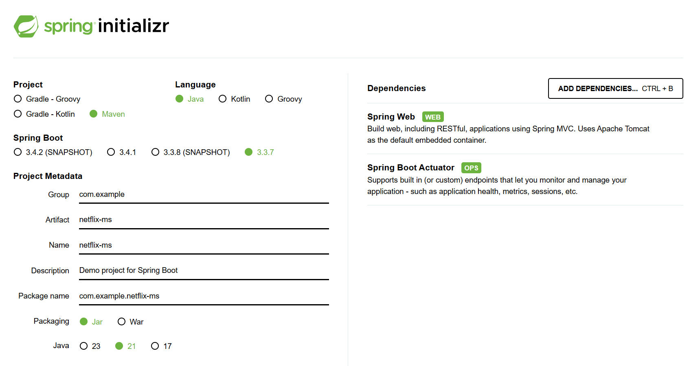

netflix.zip file will download on your local system, unzip it.

Open file, copy netflix-ms, create new folder and paste it.

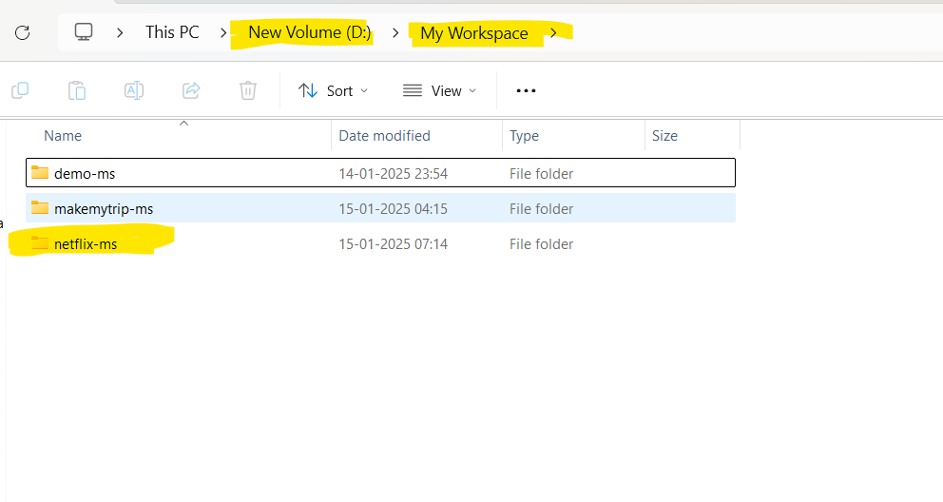

1. Open IntelliJ Idea (You have to open the netflix-ms folder in IntelliJ Idea)

File->New->Project from existing sources

Then select your project which is copied to workspace.

Select (Netflix-ms) -> Click Ok

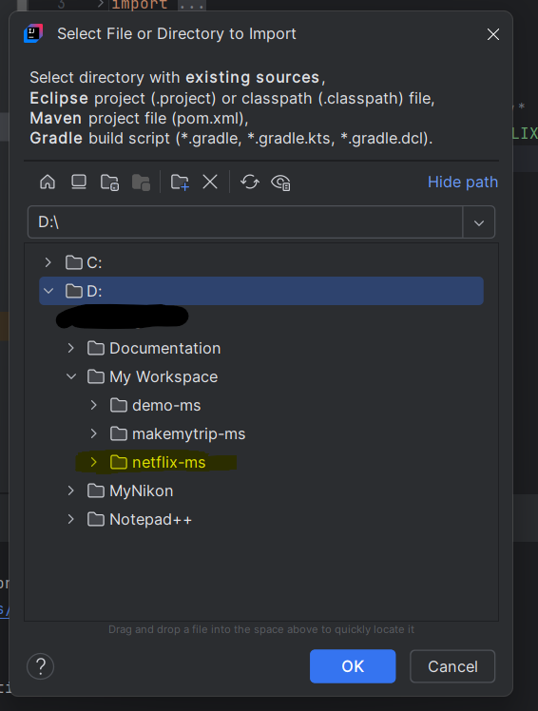

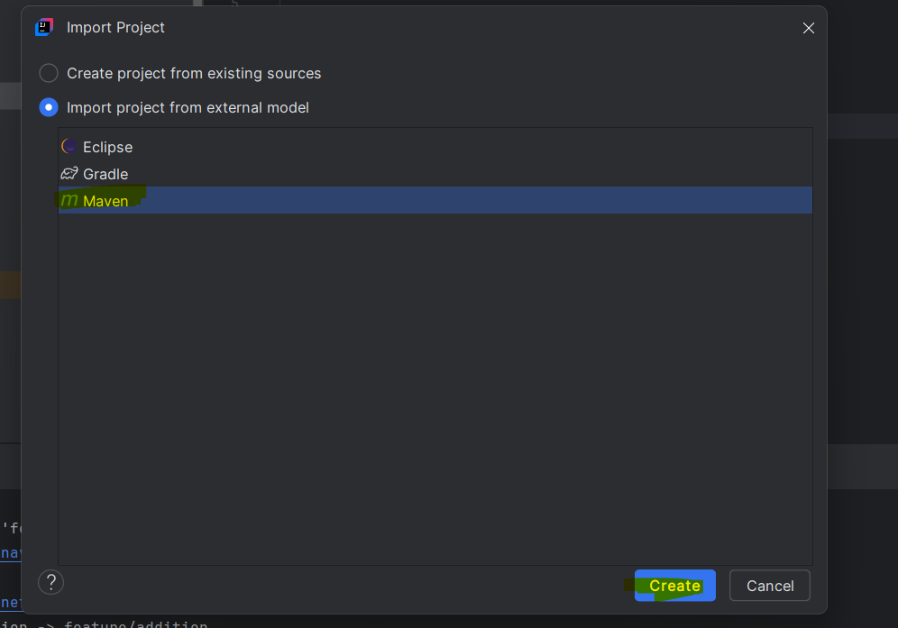

Open a project in new window.

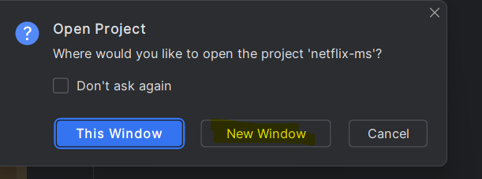

Once it opens in IntelliJ IDEA, you can compile, package, and run the project on your local system.

1. Compile the code in IntelliJ idea.

**mvn clean compile**

Once the compilation is complete, a class file (e.g., netflix.class) will be created.

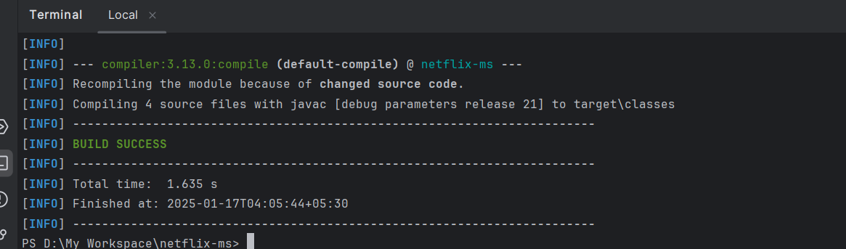

Package the code.

**mvn clean package**

Once done, jar file will be created.

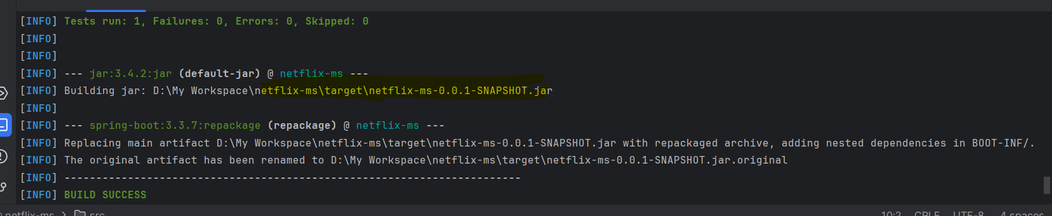

Run the Code in Local System.

**mvn spring-boot:run**

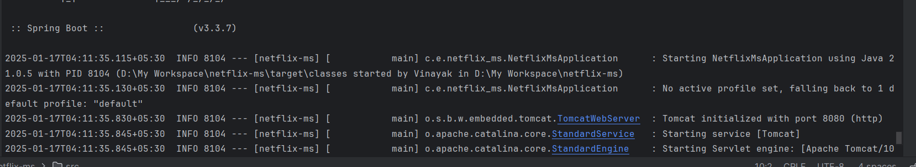

You can add class file and test the application in Local.

To add class file, follow steps below.

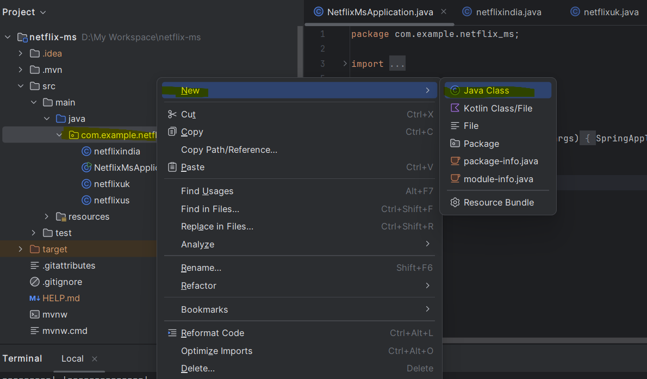

Enter a name for java class.

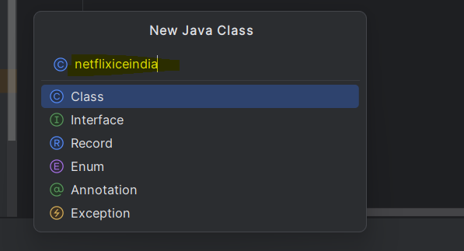

Write a code:

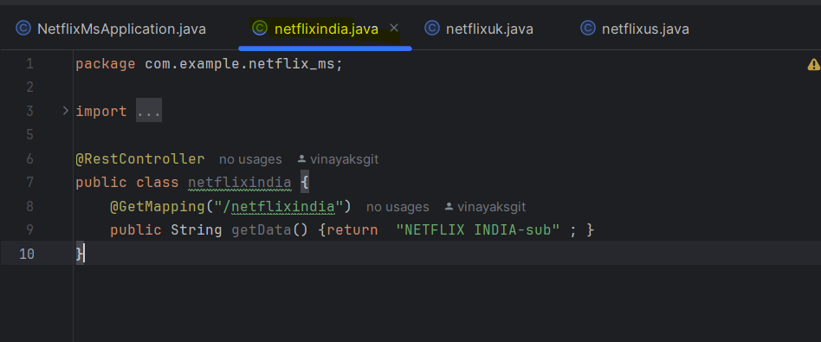

Once done. Compile, Package, Run, Test the code in Local System.

You can see the output of our program in browser. Type in address bar.

e.g. : <http://localhost:8080/netflixindia> (Path of your java class)

Once the above steps are complete, you are ready to push the code to the GitHub remote

Repository.

To push the code from your local system to the remote repository, follow the steps below.

1. Open GitHub and create new repository.

Login to your account and select repositories and click on new

Create a repository named netflix.

Select Public to access for everyone.

Select Add a README file.

Add gitignore : java (we are pushing java code into repo.)

Change the branch name to master.

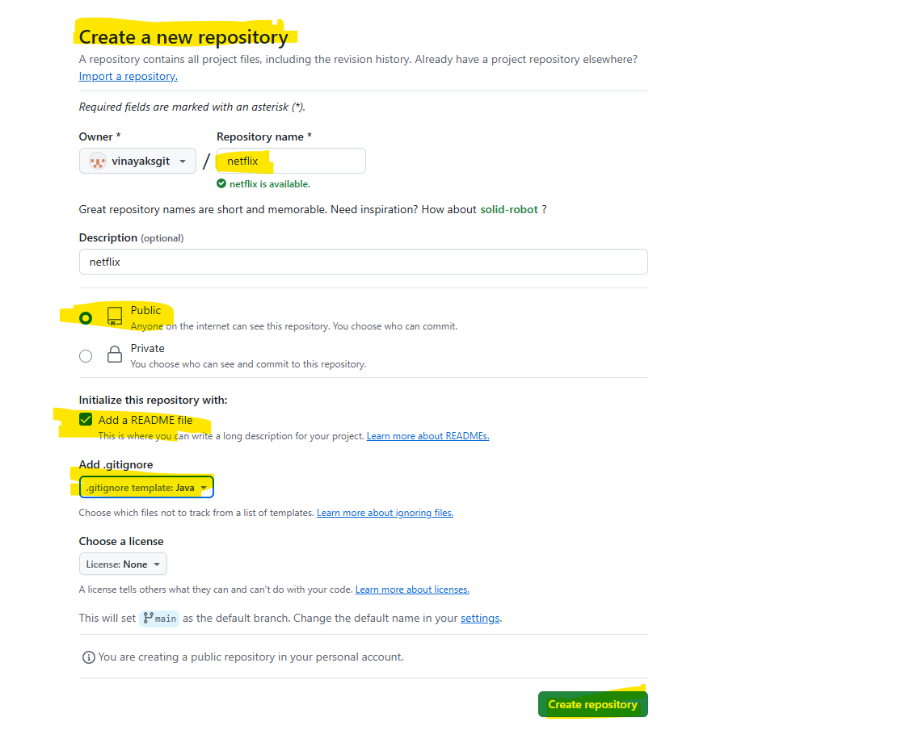

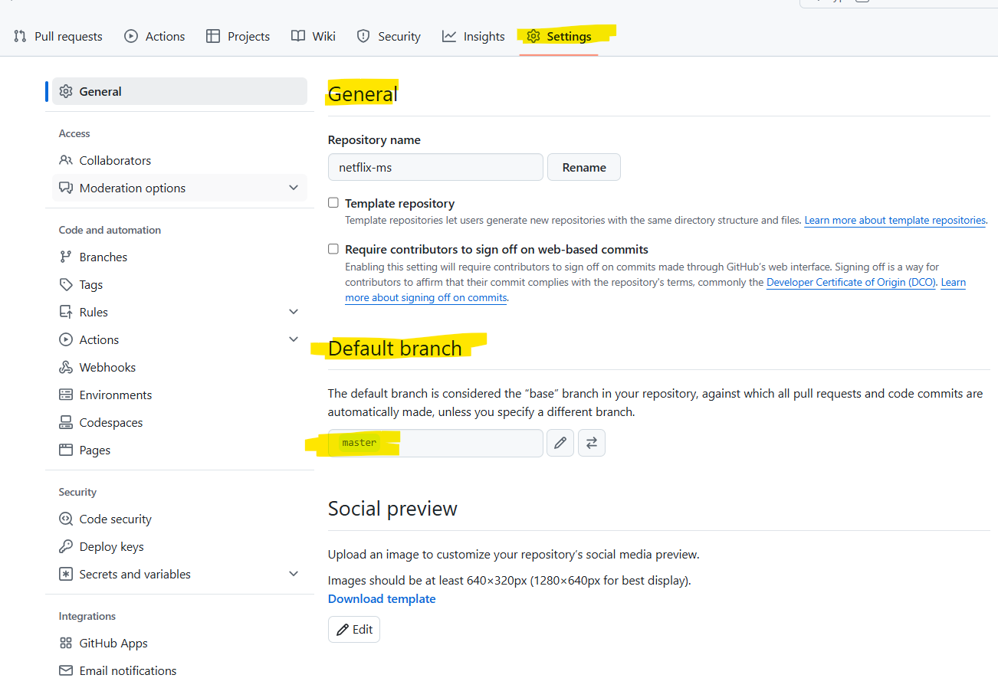

Open Intellij IDEA for linking the local repo with Git hub repo.

Click on VCS -> Enable version control Integration.

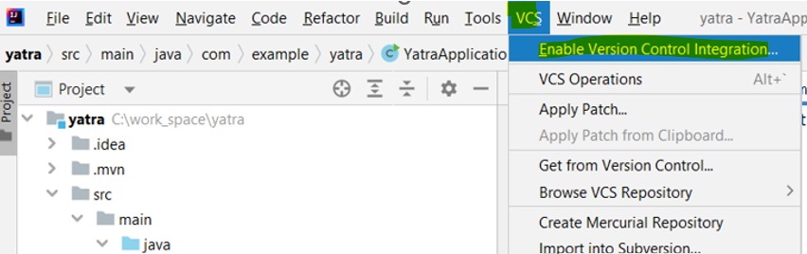

Select Git and click ok

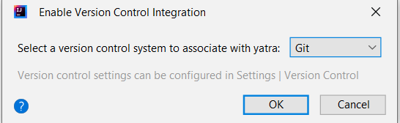

Click on Git -> Manage Remotes

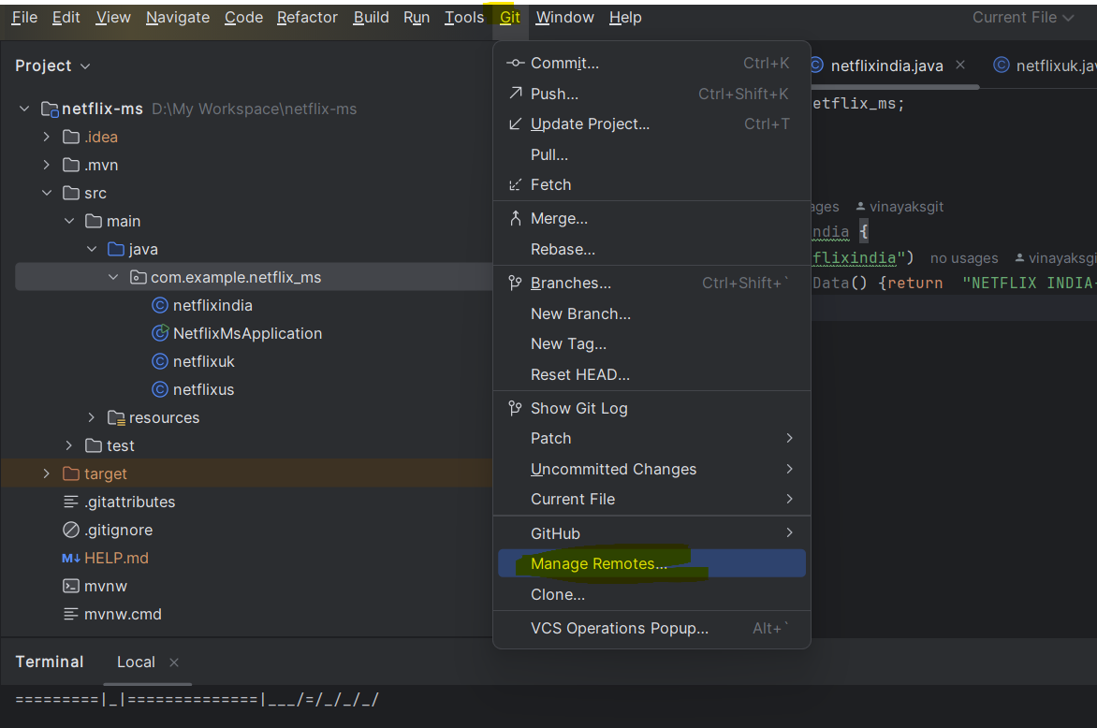

Click on + sign to add the remote repo link

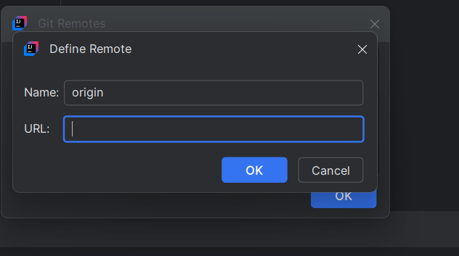

Go to GitHub for Repo link. Click on code then copy the link (HTTPS).

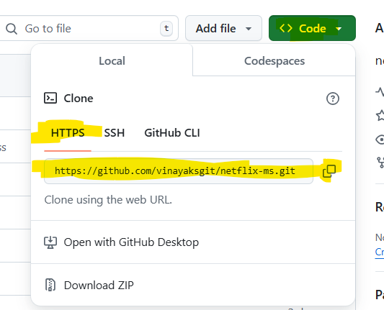

Paste it in git remote.

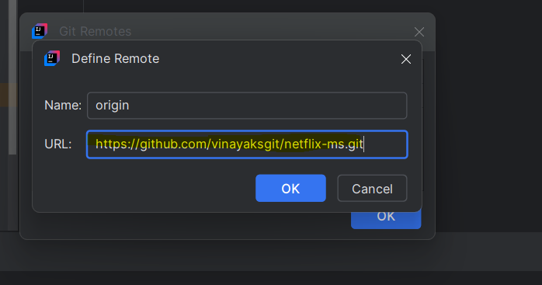

1. Once the above steps are done, Compile the code again in Intellij idea and push the code to Git hub repo.

Below are the commands to push the code from your local system to the remote repository. (These commands should be used only for the first time.)

**git pull origin master**

**git add –all**

**git commit -m “Enter the message”**

**git push origin master -f**

1. Now you can view the codes you have pushed from local to Git hub repo.

